**Packet Tracer Ex 2**

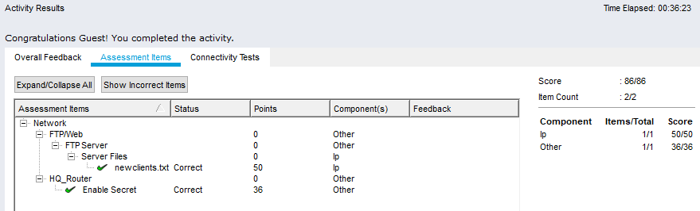

**What protocol was used to send the email to the email server?**

- SMTP (**Simple Mail Transfer Protocol**) is a protocol used in sending (outgoing) emails. SMTP is the protocol used for sending (outgoing) emails.

**What protocol was used to retrieve the email from the email server?**

- The Internet Message Access **Protocol** (IMAP) is a **mail protocol** used for accessing **email** on a remote web server from a local client.

**Why is FTP considered an insecure protocol for moving files?**

- FTP is easily vulnerable to users in a private network.

**What information is displayed in clear text from the FTP header?**

-

**Besides the username, what other sensitive information is displayed in clear text from the FTP header?**

-

**Why is Telnet considered an insecure protocol for remotely managing a device?**

-

**Why is SSH considered a secure protocol for remotely managing a device?**

-